Data Analyst ND project #1

global and local data analysis

Abstract:
this paper aims to analyze local and global data in order to compare them and get some insights after observing their representation.

Description:
first of I started extracting the data from the data base using the following commands :

1- to collect the global data after 1808 ‘to match the years of the available local data’
SELECT *
FROM global_data
WHERE year >=1808;

2- to collect Cairo’s data (the closest big city in the city_list)
SELECT *
FROM city_data
WHERE city = “Cairo”;

Then, I saved the data into CSV files and created a common CSV file that includes both the global and the local data, then I plotted their chart line as a function of the years and here is the output using LibreOfficeCALC.

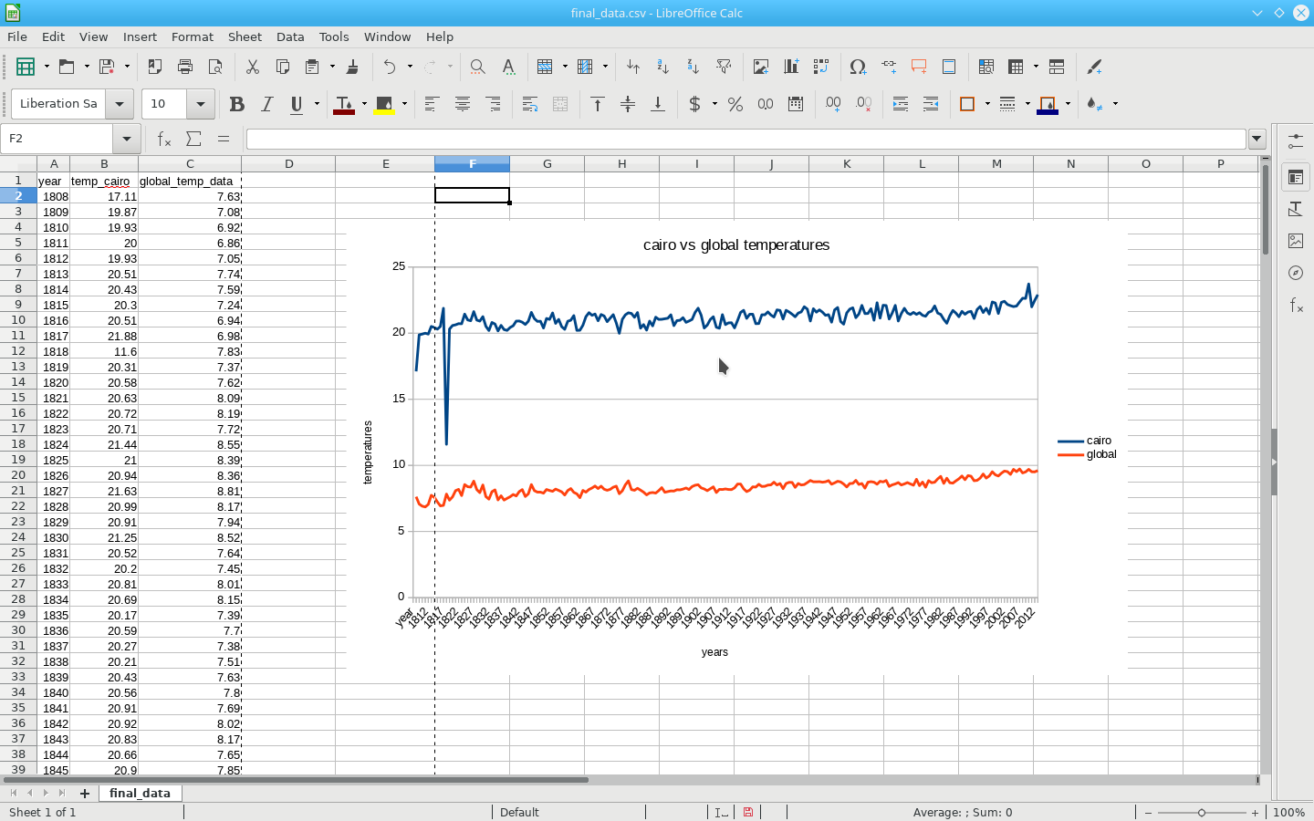
But the plot wasn’t smooth,to make it more smooth I plotted the chart line of the moving average per each 10 years, and here’s the output using
1- LibreOfficeCALC.
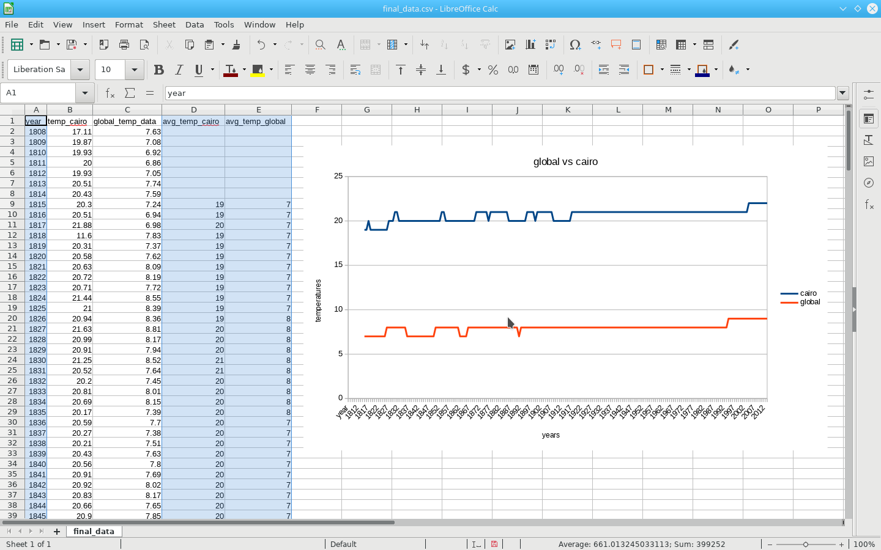
2- Python.

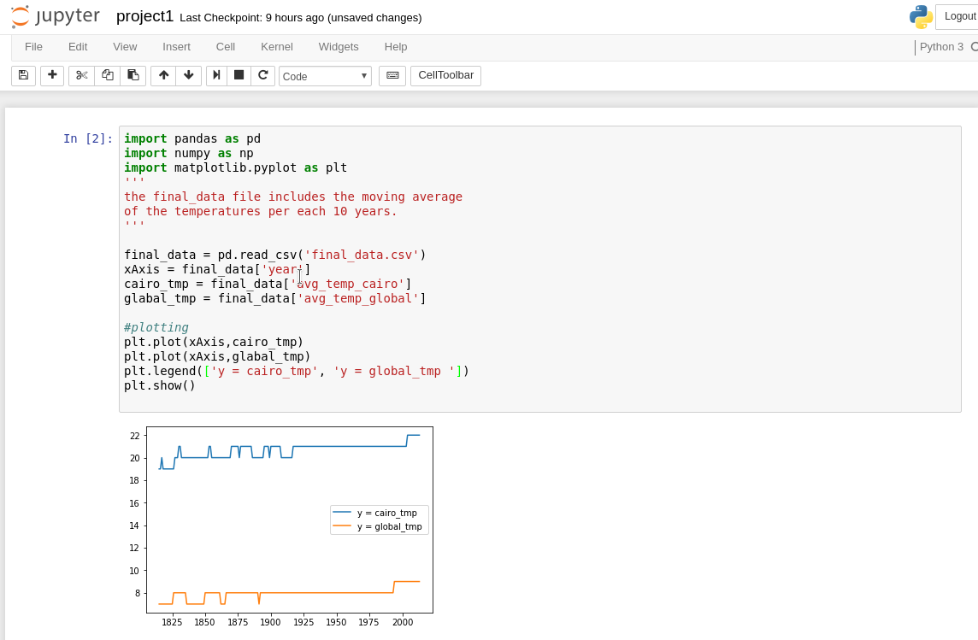
Conclusion:

here are the observations :
- Cairo is by far HOTTER than the average global temperatures.
- Cairo and Global temperatures difference is almost consistent over the time, specifically in the 20th century.
- The ups and downs (change) in the temperature is almost similar specifically in the 20th century.
- Starting from the 90’s, both the global and Cairo’s temperature are getting Hotter.
- Over the last century, the trend was consistent until the 80’s, where the temperature started to get hotter.
- Cairo’s coolest temperature was between the years 1808 – 1825 and the Hottest years are starting from the 21th century.
- The coolest Global temperature was between the years 1835 and 1850 and the Hottest are after the 90’s of the 20th century.

